BIG DATA ANALYSIS FOR EDUCATION,CRIME AND
DEPRIVATION USING HADOOP,HIVE,SPARK AND ZEPPELIN
EMAIL:- Emani-KPK@ulster.ac.uk
Student no:- B00819618
Ulster University, Jordanstown campus

Abstract—the paper produces a short information of what is Big Data, technologies utilized to develop a Big Data infrastructure and how it can be helpful in the development of a nation. the paper explores the different possibilities that big data can produce with prospect to enhance decision-making in vulnerable development areas such as Education, Crime and Deprivation. the variety of assumptions depend on the reality available are developed to create a model for the nation enhancement. the paper en-corporate the result of performing big data in different fields. it explains the opportunities that are helpful in policy and decision making with support of big data.
Keywords— BIG DATA, HADOOP, HIVE, SPARK AND ZEPPLIN NOTEBOOK

- DISCUSSION OF PROBLEM
big data as its word refers is a data that is huge amounts, faster. and difficult. currently because of increased utilization of internet, digital resources, mobile gadgets, sensors, social networking sites, satellite images etc... huge quantity of digital information generated per minute. these data can be stored in the shape of digital pictures, posts, videos and blogs. Big data implies to addition of very large datasets which consists data in various formats, that is unstructured data. we can use these data for decision making and current trend in education, crime. and deprivation. for this usage the digital data represented in the world has to be preserved and examined.
the information stored is more than petabytes each day quintillion bytes of data are formed which can be helpful for the development of society. improving required domains and decision making etc. Big data manages with importing data from different from different platforms and in different forms and preserving below unified schemas for analysis. The decision-making method can be technical and processed by advent of big data. loads of research is currently going on to hire big data technology in different domains for developing decision making in education, crime and deprivation. the paper priorly concentrated on how to employ Big Data technology in different domains

development in decision making and policy making for the countries. it can give solutions and describe the operations for the improvement of different domains like education, crime and deprivation Big data implies to a data that is huge enough with refers to volume, variety and velocity, volume- huge amount of data higher than Exabyte. different-huge data set of information in the form of
images, videos, texts etc. velocity- rate at which these data are produced. a huge store of data is being generated day by day we implies this as a big data. Big data is not able to preserved on a single machine, we required parallel system architecture and shared systems
infrastructure to preserve this data. since information started from various sites and in various locations.
it has to be preserved in uniform shape, later these data is utilized for analytics usage.
Big data analytics implies to identifying knowledge from data, it changes the unstructured data into structured utilizing various approaches.
analyzing these big data permits us to identify the correlation, facts, and important data that hides in this huge dataset, which is not possible to be represented by human.
the data from different sources are gathered, they are pre-processed and preserved under uniform schemas. this data later analyzed into form of reports, graphs, spatial charts.
Diagrams and tables which can be utilized for numerous decisions making. updating trends in online news or social media can provide information on evolution and patterns at the small level which can be mostly relevant to development.
big data analytics implies to tools and methodologies that aim to change huge quantities of raw data into useful data for data analytics purpose they are mainly depending upon the algorithms that are capable to predict patterns, trends and correlations over various time zones in data, but also on enhanced visualization techniques as sense making tool. the data is acquired from different sources.
it is aggregation of structured, unstructured and semi structured data which is transformed into uniform schema and then high analysis tools, mining algorithms are deployed for carrying out the facts and trends.
The process of carrying out big data analysis involves mainly into five stages
1)importing datasets: importing all kind of datasets in a huge amount which is in different forms.
2)data preprocessing: - in order to perform we need to change unstructured data into useful data.
3)storing data :it is very important to store a data in data storage like HDFS which is scalable.
4)analytics : we are using hive and spark to perform exploratory data analytics
5)data visualizations: - perform data visualization using zeppelin notebook.

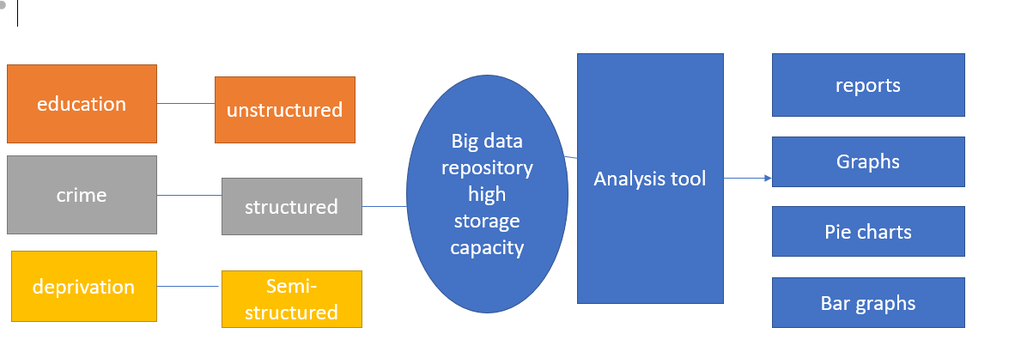

II) JUSTIFICATION OF DATA-SETS
Big data can be employed in different domains discussed below the exploration of big data can be highly useful. different fields like education, crime and deprivation etc. this section will put light on some areas which can benefited by big data exploration
Education: -in Education domain historical data of all students, educational domain and their rankings based on each ward code can help us to carry out important data analysis and correlation between
each ward and their educational domain and rankings help us to identify vulnerable areas to develop.
Time period explains about their performance in each respective academic year.
Crime: crime dataset has been systematically noted by the police for numerous years and in the previous ten years there has been a operation of police crime records and apps/ web based applications
displaying crime statistics on maps, both by police uk and other sources utilizing the same official data.
these data can be utilized to help decision making by the police, marketing agencies and the government.
“The statistics contained in these datasets reflect the number of crimes reported to and recorded by the police. To ensure consistency, police recording practice is governed by Home Office Counting Rules (HOCR) and the National Crime Recording Standard (NCRS). These rules provide a national standard for the recording and classifying of notifiable offences by police forces in England and Wales. Although the Police Service of Northern Ireland does not fall under the jurisdiction of the Home Office, the same recording practices are followed and applied within Northern Ireland. Crime recording quality assurance processes within PSNI are designed to minimize the level of missed crime and to ensure that the correct crime type is recorded. Please refer to the User Guide to Police Recorded Crime Statistics in Northern Ireland on the PSNI website for further information on data quality, caveats to be aware of when examining trends in police recorded crime data and the
Northern Ireland Crime Survey as an alternative but complementary measure of crime” [2]
“The 2010 Northern Ireland Multiple Deprivation Measure (NIMDM 2010) comprises seven domains of deprivation, each developed to measure a distinct form or type of deprivation.
The NIMDM 2010 is a combination of all seven deprivation domains, weighted as follows: Income Deprivation (25%); Employment Deprivation (25%); Health Deprivation and Disability (15%); Education Skills and Training Deprivation (15%); Proximity to Services (10%); Living Environment (5%); and Crime and Disorder (5%).
Results are provided for these domains and the overall multiple deprivation measure in the form of ranks. Areas are ordered from most deprived (rank 1) to least deprived. The main output geography for the deprivation measures is the Super Output Area.
The Northern Ireland Multiple Deprivation Measure 2010 report is available at https://www.nisra.gov.uk/publications/northern-ireland-multiple-deprivation-measure-2010.[1]
Please note that the csv deprivation files were created by the Open Data Team as a sample csv for NISRA”.[1]
III) TOOLS AND METHODOLOGIES
these fields represent the technologies utilized to developed a huge data architecture. initially we required some storage capabilities which will preserve our big data. for that we can utilize open-source tools like Hadoop Distributed File System
An Ambari open-source distributed file system, it runs on high performance customized hardware called as highly scalable storage with fault tolerance, back-up and write once read as many times.
Ambari sandbox: provides a cluster wide, real-time interface of clusters and nodes with services running gives a single, flexible to configuration changes all over the cluster and integrates full
performance and services of reporting and diagnostic tools with full server and each clutter check to optimize cluster performance and usage. database abilities for executing big data architecture can be integrated by required tools
Ambari Hadoop: -highly scalable equal batch operations. effectively customizable service. saves and writes multiple copies all over cluster for fault tolerance
Ambari Hive: - tools to enable fast data extraction, transformation and load(ETL) from files located either directly in Ambari HDFS or any different data storage machines like Hbase

IMPLEMENTATION OF HIVE QUERIES USING CRIME DATASET
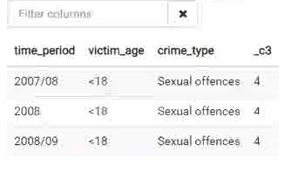FIG 2 implementation of hive queries in order to extract victim age groups less than 18
QUERY USED: select time_period, victim_age, crime_type, count(*) from police_crime_records where victim_age RLIKE '<18' and time_period RLIKE '2007|2008' and crime_type = 'Sexual offences' group by time_period, victim_age, crime_type;
IMPLEMENTATION OF HIVE QUERIES USING EDUCATION DATASET
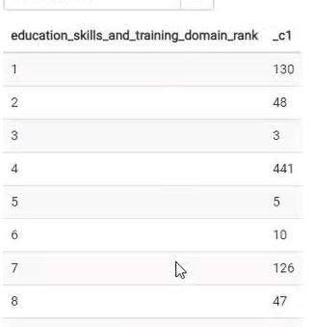
FIG 3 implementation of education and training domain rank based on the ward.
QUERY USED:- SELECT education_ward_code as SELECT education_skills_and_training_domain_rank, COUNT(ward_code)
FROM concat GROUP BY education_skills_and_training_domain_rank;
IMPLEMENTATION OF HIVE QUERIES USING DEPRIVATION DATASET
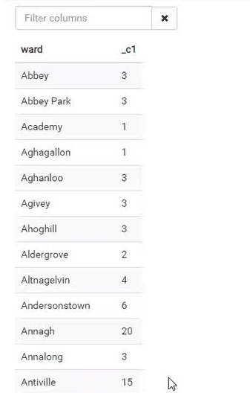
FIG 4:- IMPLEMENTATION OF CRIME AND DEPRIVATION RANKINGS BASED ON EACH WARD NAME ACCORDING TO THEIR ALPHABETICAL ORDERS
QUERYUSED: - SELECT ward, COUNT (crime_and_disorder_domain_rank)
FROM concat GROUP BY ward;
IMPLENTATION OF SPARK QL USING ZEPPLIN NOTEBOOK
Ambari Spark: - spark is a cluster computing framework developed to perform scalable programs that may be utilized within a Hadoop cluster. spark reduce the difficulty and issues of preprocessing data stored within Hadoop and , typically, produced quick implementation.
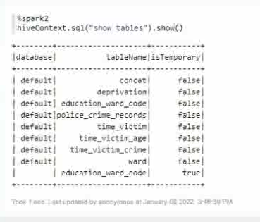
FIG 5 IMPLEMENTATION SPARK QUERY TO EXTRACT NECESSARY TABLES TO PERFORM ANALYSIS.
IV). DATA VISUALIsATIONS USING ZEPPELIN NOTEBOOK.
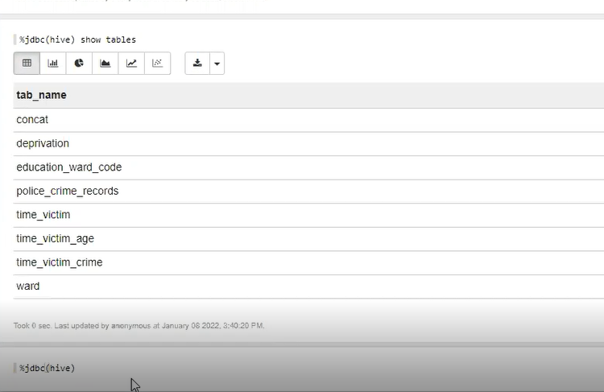
FIG 6:- IMPLEMENTATION OF HIVE TABLES TO PERFORM DATA VISUALISATIONS
QUERY USED:- %jdbc(hive) show tables;

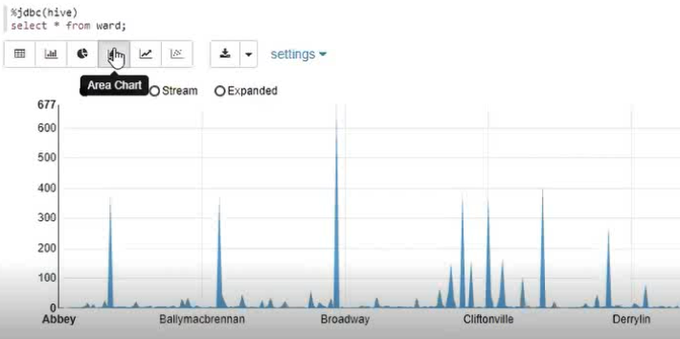
FIG 7 IMPLEMENTATION OF HIVE TABLES TO PERFORM CORRELATION BETWEEN EDUCATION AND DEPRIVATION DATA
In the above figure the education rank varies depends on the different ward names so it is explaining the correlation between education and deprivation dataset.
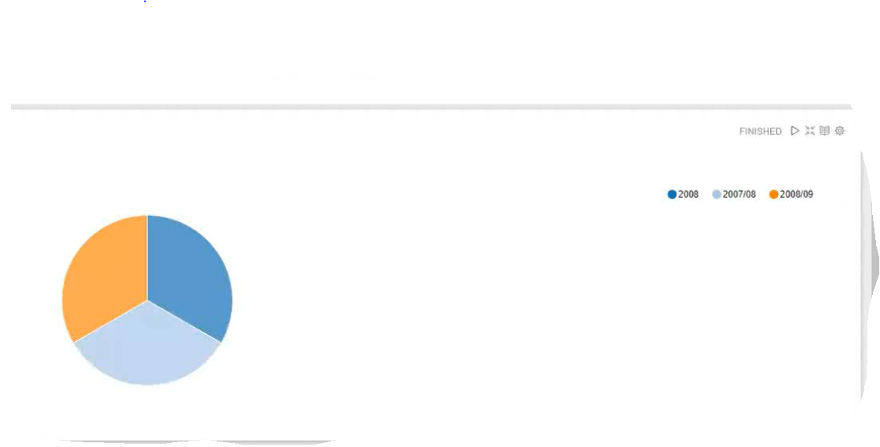
FIG 7 :- REPRESENTS THE ANALYSIS OF TIME PERIOD AND VICTIM AGE OF CRIME
QUERY USED :- %jdbc(hive)
Select * from time_victim;
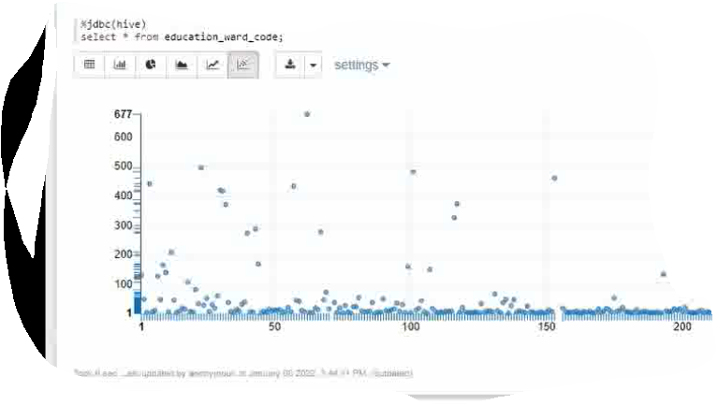
FIG 8:THE RATE OF EDUCATION VARIED FOR DIFFERENT WARD CODES
REFERENCES:-1) https://www.opendatani.gov.uk/dataset/https-www-nisra-gov-uk-statistics-deprivation
2) https://www.opendatani.gov.uk/dataset/police-recorded-crime-in-northern-ireland

